|  |
| --- |
| IE 529 |
| Stats of Big Data & Clustering |
| Computational Assignment: 1 |
| **Zhenye Na(zna2)** |

**I. Principal Component Analysis: real data**

1. For the given data, de-mean each entry, using column sample means. Perform a PCA on the demeaned data. Clearly explain how you performed the PCA (submit pseudocode for your own PCA code, or reference and describe any function you called, i.e., from what library, how it works, what it takes as inputs and produces as outputs).

load ('PCA_comp1.mat'); % Load raw data into OCTAVE

[X_norm, mu, sigma] = **Normalization**(X); % First, normalize X (subtract mean & divided by sigma)

[U, S] = **pca**(X_norm); % Then, run PCA on dataset

% Normalization function: perform normalization to the input data

**function** [X_norm, mu, sigma] = **Normalization**(X)

% compute the column mean

mu = mean(X);

% subtract column mean from original matrix

X_norm = bsxfun(@minus, X, mu);

% compute sigma

sigma = std(X_norm);

% divide the normalized matrix by sigma

% X_norm = bsxfun(@rdivide, X_norm, sigma);

**end**

% pca function: perform PCA

**function** [U, S] = **pca**(X)

[m, n] = size(X);

Y = (1 / (m - 1)) * X' * X; % Compute covariance matrix YTY

[U, S, V] = svd(Y); % Perform SVD on covariance matrix

**end**

Pseudo-code:

1. Preprocessing: Subtract the *mean* and divided by *sigma*
2. Compute covariance matrix *SIGMA*
3. Compute ‘eigenvectors’ of matrix *SIGMA*
4. Select *k* appropriate principal components

2. State what portion of the variance in the data is contained in each of the 4 principal components. From these values, state how many true components are needed to represent the data.

proportion = zeros(size(S, 1), 1);

denominator = sum(sum(S));

% compute the proportion of retained variance

for i = 1:size(S, 1)

I = ones(i, 1);

numerator = sum(S(1:i, 1:i) * I);

proportion(i) = numerator / denominator;

end

% display the proportion matrix

disp(proportion);

Output:

0.9246162 % 1st principal component variance retained proportion

0.0530156 % 2nd principal component variance retained proportion

0.0171851 % 3rd principal component variance retained proportion

0.0051831 % 4th principal component variance retained proportion

Actually we should pick the smallest value of K (# of principal components) for which keeps 99% of variance retained. ***So in this case we only need 3 principal components to represent the data.***

3. On a 2D graph with the horizontal axis given by the ﬁrst PC, and the vertical plot given by the second PC, plot the 2D representation of all the data points (i.e., ﬁnd the 2D projection of each row). Discuss: (a.) are there any visually apparent clusters, if so, how many, and (b.) from this do you think you can conjecture anything about the number of species represented by the data?

Ureduce = U(:,1:2); % reschedule the number of principal components

Z = X_norm * Ureduce; % generate the projection Z

scatter(Z(:, 1), Z(:, 2)); % plot the scatter plot

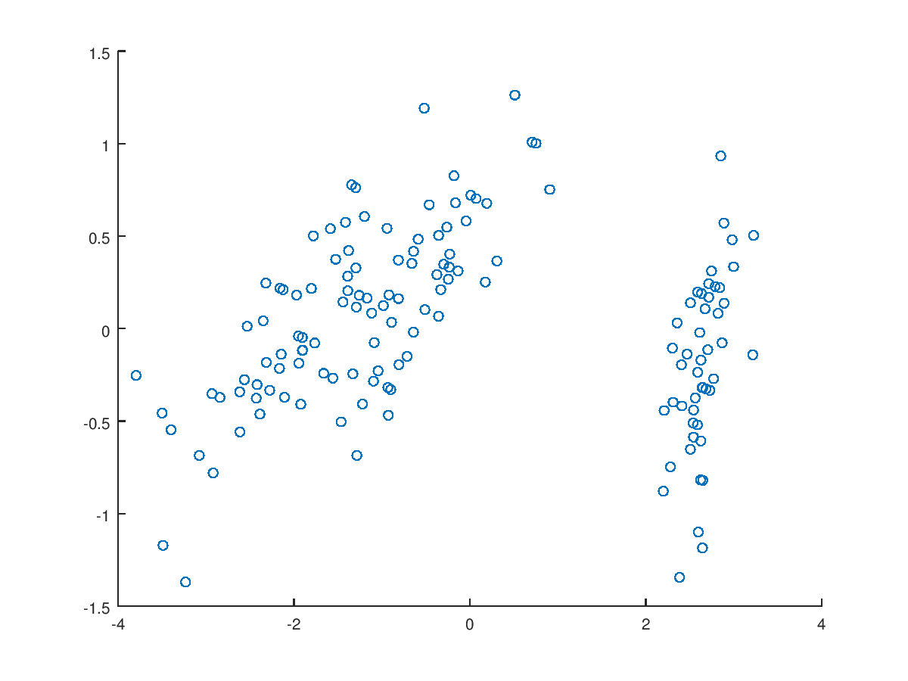

1. There are 2 obvious clusters.
2. There are 2 separate species.

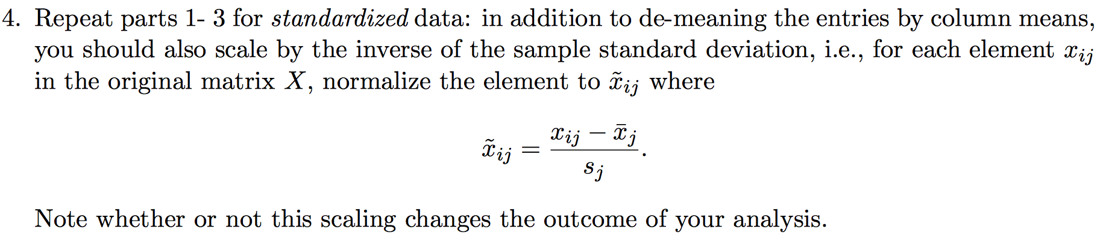

load ('PCA_comp1.mat'); % Load raw data into MATLAB/OCTAVE

[X_norm, mu, sigma] = **Normalization**(X); % First, normalize X

[U, S] = **pca**(X_norm); % Run PCA

% Normalization function: perform normalization to the input data

**function** [X_norm, mu, sigma] = **Normalization**(X)

% compute the column mean

mu = mean(X);

% subtract column mean from original matrix

X_norm = bsxfun(@minus, X, mu);

% compute sigma

sigma = std(X_norm);

% divide the normalized matrix by sigma

X_norm = bsxfun(@rdivide, X_norm, sigma);

**end**

% pca function: perform PCA

**function** [U, S] = **pca**(X)

[m, n] = size(X);

Y = (1 / (m - 1)) * X' * X; % Compute covariance matrix YTY

[U, S, V] = svd(Y); % Perform SVD on covariance matrix

**end**

proportion = zeros(size(S, 1), 1);

denominator = sum(sum(S));

% compute the proportion of retained variance

for i = 1:size(S, 1)

I = ones(i, 1);

numerator = S(i, i);

proportion(i) = numerator / denominator;

end

% display the proportion matrix

disp(proportion);

Output:

0.7277045 % 1 principal component variance retained proportion

0.2303052 % 2 principal components variance retained proportion

0.0368383 % 3 principal components variance retained proportion

0.0051519 % 4 principal components variance retained proportion

Ureduce = U(:,1:2); % reschedule the number of principal components

Z = X_norm * Ureduce; % generate the projection Z

scatter(Z(:, 1), Z(:, 2)); % plot the scatter plot

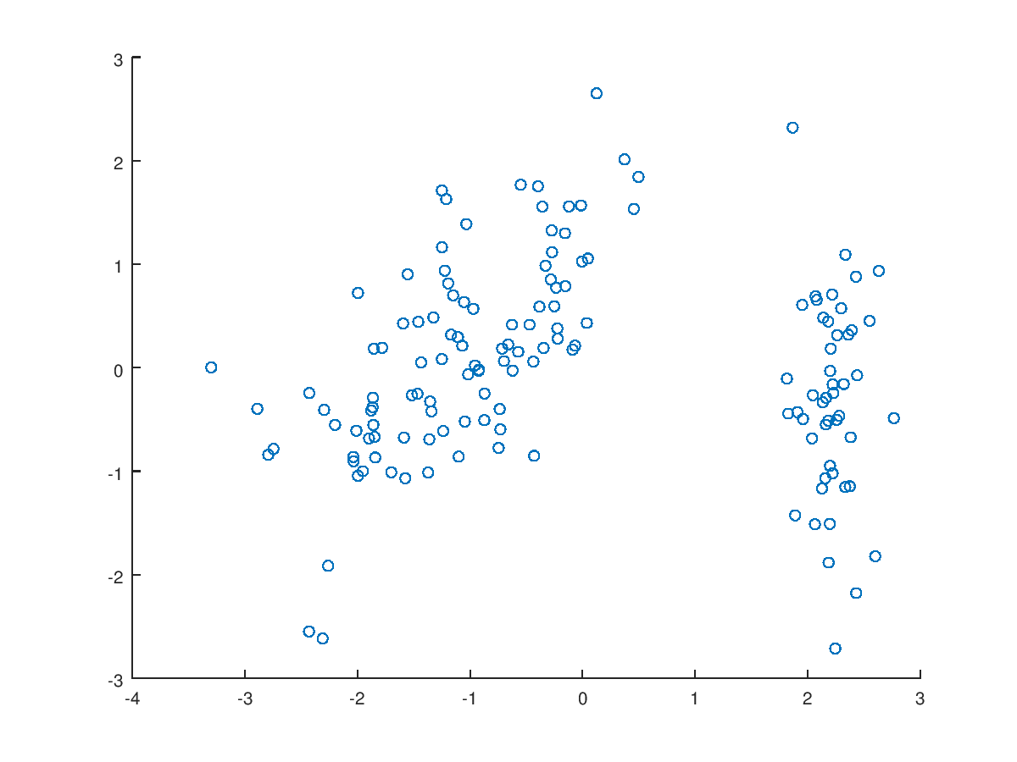

1. There are 2 obvious clusters. (b.) There are 2 separate species.

5. Turn in a report including (a) a matrix with the 4 components for the data and their associated variances, and (b) plots for parts 3 and 4 (i.e., for both the demeaned and the standardized data sets).

(a)

disp(U); % display the principal components

disp(S); % display the eigenvalues which is their associated variance

**% BELOW IS MATRIX GENERATED BY SCALED DATA**

-0.522372 -0.372318 0.721017 0.261996

0.263355 -0.925556 -0.242033 -0.124135

-0.581254 -0.021095 -0.140892 -0.801154

-0.565611 -0.065416 -0.633801 0.523546

2.910818 0 0 0

0 0.921221 0 0

0 0 0.147353 0

0 0 0 0.020608

**% BELOW IS MATRIX GENERATED BY UNSCALED DATA**

-0.361590 -0.656540 0.580997 0.317255

0.082269 -0.729712 -0.596418 -0.324094

-0.856572 0.175767 -0.072524 -0.479719

-0.358844 0.074706 -0.549061 0.751121

4.224841 0 0 0

0 0.242244 0 0

0 0 0.078524 0

0 0 0 0.023683

(b) Plots see previous pages.

**II. Regression analysis:**

1. **Write a simple program** to compute a least squares solution for the case of linear or polynomial regression, and determine the lowest order model that ﬁts the data reasonably well (order 1 is linear, and higher orders are polynomial).

**Case 1: linear regression**

% Load data to OCTAVE

load ('Comp1_IE529.mat');

X = lift_kg'; % 62x1 vector

y = putt_m'; % 62x1 vector

X = [ones(size(X, 1), 1) X];

theta = inv(X' * X) * X' * y

**Output** *(ignored the sigma and r output)*

beta =

5.679442

0.099479

residual = 94.583 *(sum of squares of r)*

**Case 2: Polynomial Regression**

% Load data to OCTAVE

load ('Comp1_IE529.mat');

X = lift_kg'; % 62x1 vector

y = putt_m'; % 62x1 vector

residual = zeros(15, 1);

X = [ones(size(X, 1), 1) X X .^ 2 X .^ 3];

Theta = inv(X' * X) * X' * y;

pred = X * Theta;

residual = (pred - y)' * (pred - y);

residual

Output:

residual = *(sum of squares of r)*

51.08726 % order = 2

44.57859 % order = 3

44.47092 % order = 4 and so on….

44.05494

43.98594

43.98366

**Based on the results of the residuals:**

When it comes to linear regression, the residual is 94.583 which is highly large. When it comes to polynomial regression, when n=2, residual is 51.087 and n=3, residual is 44.579. However, when n=4, residual is 44.471 which has no much apparent differences compared to 44.579. In conclusion, I will select ***Polynomial Regression and n=3.***

2. Consider using an existing logistic regression function in MATLAB or Python to determine if a logistic model will ﬁt the data much better or not. Discuss.

For logistic regression, we consider it as a binary classification, that is the Y of data is 0 or 1. In this case, this dataset is not appropriate for this regression.

Considering multinomial logistic regression, this dataset is also not suitable because this dataset consists continuous value not discrete categories. Even though multinomial logistic regression is used to predict categorical placement in or the probability of category membership on a dependent variable based on multiple independent variables.

Considering performing logistic regression based on the result of K-means.

Considering 3 clusters:

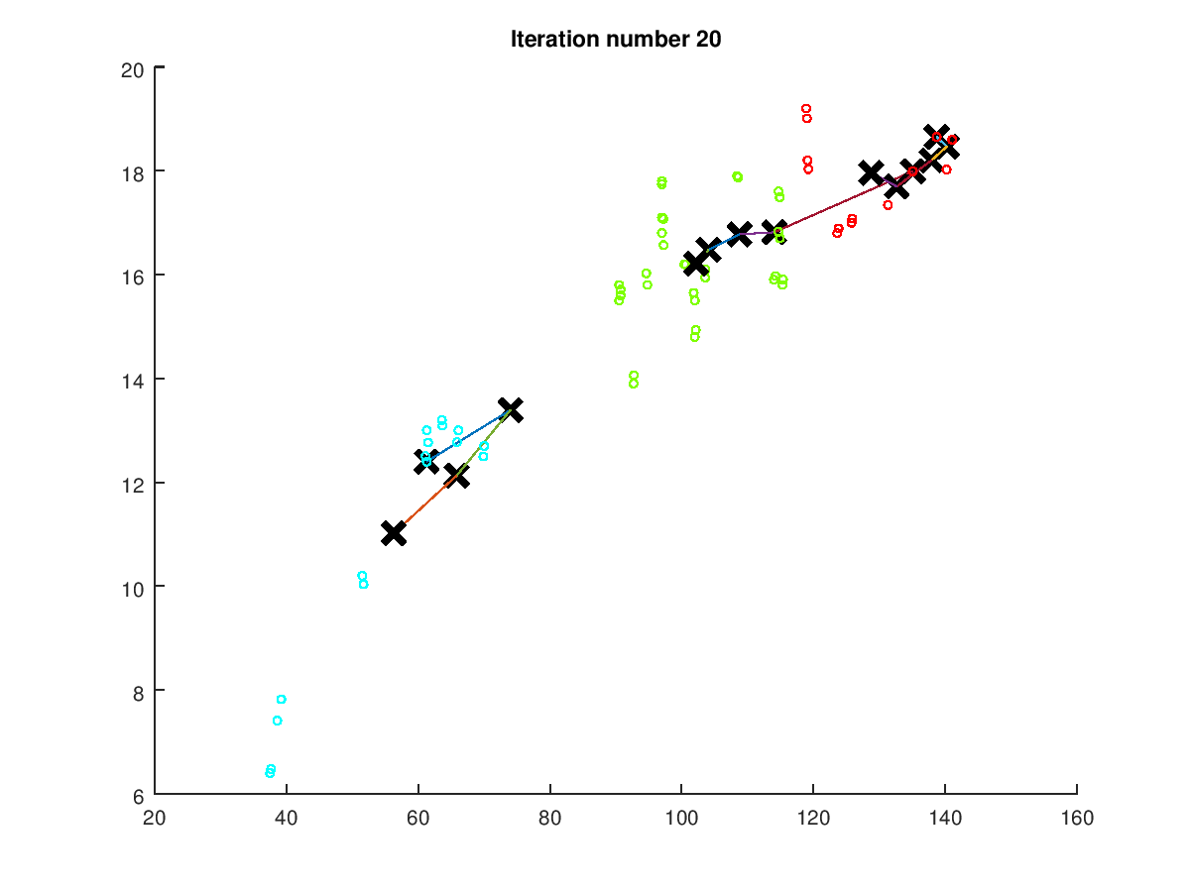

Considering 2 clusters:

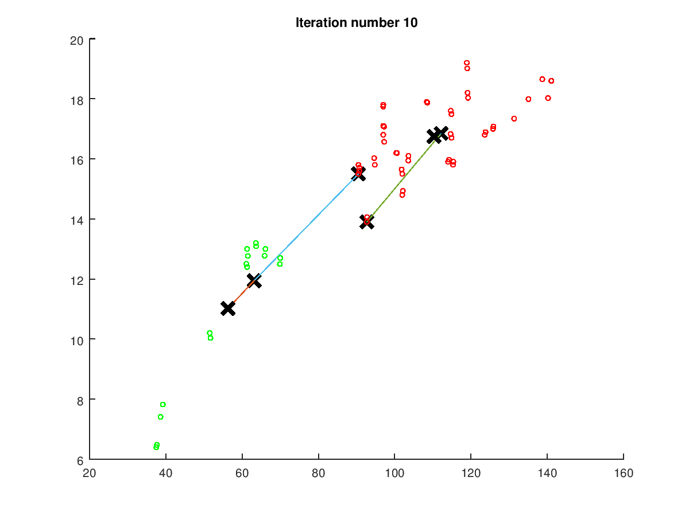

% Load an example dataset that we will be using

load ('Comp1_IE529.mat');

x = lift_kg'; % 62x1 vector

y = putt_m'; % 62x1 vector

X(:, 1) = x;

X(:, 2) = y;

max_iters = 10;

% Select an initial set of centroids

K = 2; % 2 Centroids

% Find the closest centroids for the examples using the

% initial_centroids

idx = findClosestCentroids(X, initial_centroids);

initial_centroids = kMeansInitCentroids(X, K);

% Compute means based on the closest centroids found in the previous part.

centroids = computeCentroids(X, idx, K);

% Run K-Means algorithm. The 'true' at the end tells our function to plot

% the progress of K-Means

[centroids, idx] = runkMeans(X, initial_centroids, max_iters, true);

centroids

centroids =

110.298 16.743

56.285 11.017

% Load data

load ('Comp1_IE529.mat');

x = lift_kg'; % 62x1 vector

y = putt_m'; % 62x1 vector

[x_sort, x_idx] = sort(x);

y_sort = y(x_idx);

X1 = x_sort(1:sum(x_sort <= 80));

Y1 = zeros(size(X1, 1), 1);

X2 = x_sort(size(X1, 1) + 1:end);

Y2 = ones(size(X2, 1), 1);

y = [Y1; Y2];

% % Add intercept term to x and X_test

X = [ones(size(x_sort, 1), 1) x_sort];

initial_theta = zeros(n + 1, 1);

options = optimset('GradObj', 'on', 'MaxIter', 400);

% Run fminunc to obtain the optimal theta

% This function will return theta and the cost

[theta, cost] = ...

fminunc(@(t)(costFunction(t, X, y)), initial_theta, options);

theta

cost

pred = sigmoid(X * theta);

xx = linspace(min(X(:,2)), max(X(:,2)), 62);

plot(X, y, 'o', xx, pred, '-')

theta =

-49.32699

0.60995

cost = 2.5143e-04

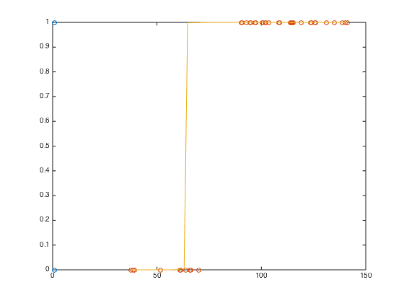

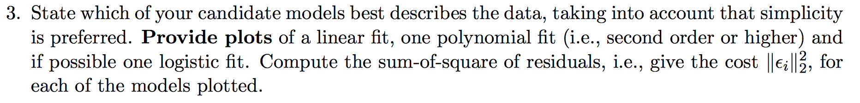

Case 1: Linear Regression

**plotDataLR**(X, y);

% Plot the linear fit

hold on; % keep previous plot visible

plot(X, [ones(size(X, 1), 1) X] * beta, '-')

legend('Training data', 'Linear regression')

hold off % don't overlay any more plots on this figure

% ---------------------------------------------------------------------------------------------- %

function **plotDataLR**(x, y)

figure; % open a new figure window

load ('Comp1_IE529.mat');

X = lift_kg'; % 62x1 vector

y = putt_m'; % 62x1 vector

m = length(y);

plot(x, y, 'rx', 'MarkerSize', 10);

**end**

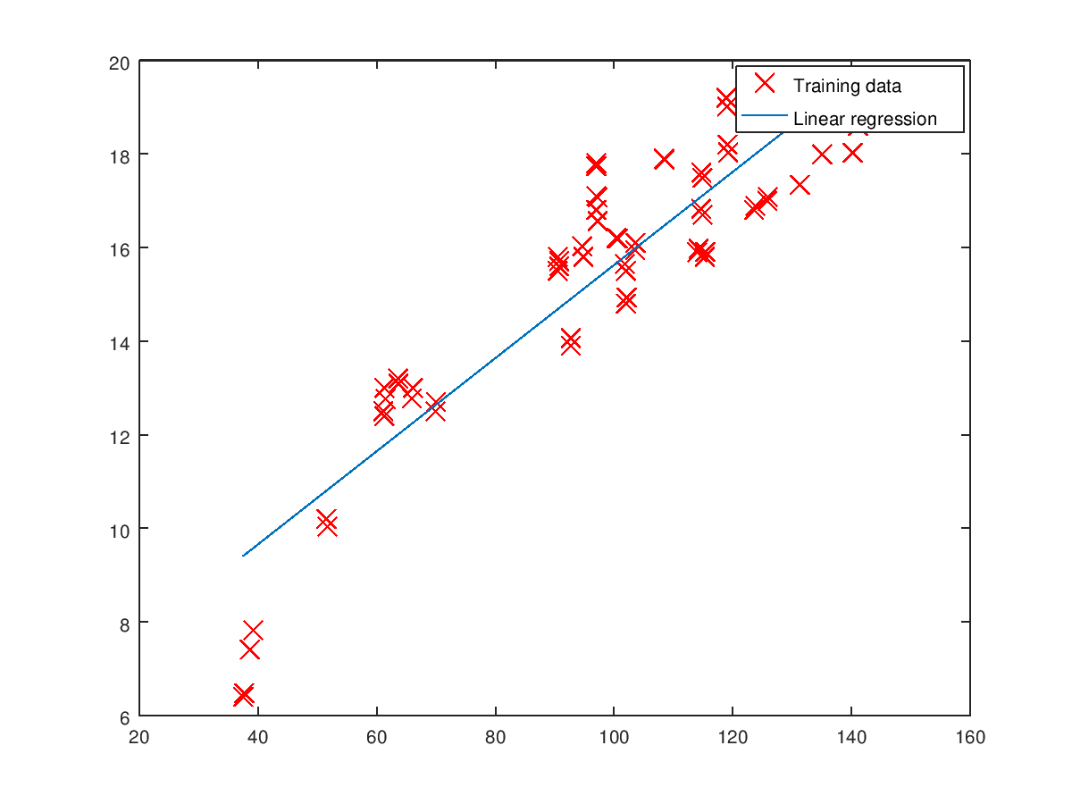

residual = 94.583

Case 2: Polynomial Regression

% Load data

load ('Comp1_IE529.mat');

X = lift_kg'; % 62x1 vector

y = putt_m'; % 62x1 vector

p = polyfit(X, y, 2);

pred = polyval(p,X);

residual = [pred - y]' * [pred - y];

t2 = 0:0.1:max(X);

y2 = polyval(p,t2);

plot(X,y,'o',t2,y2)

legend('Training data', 'Polynomial regression');

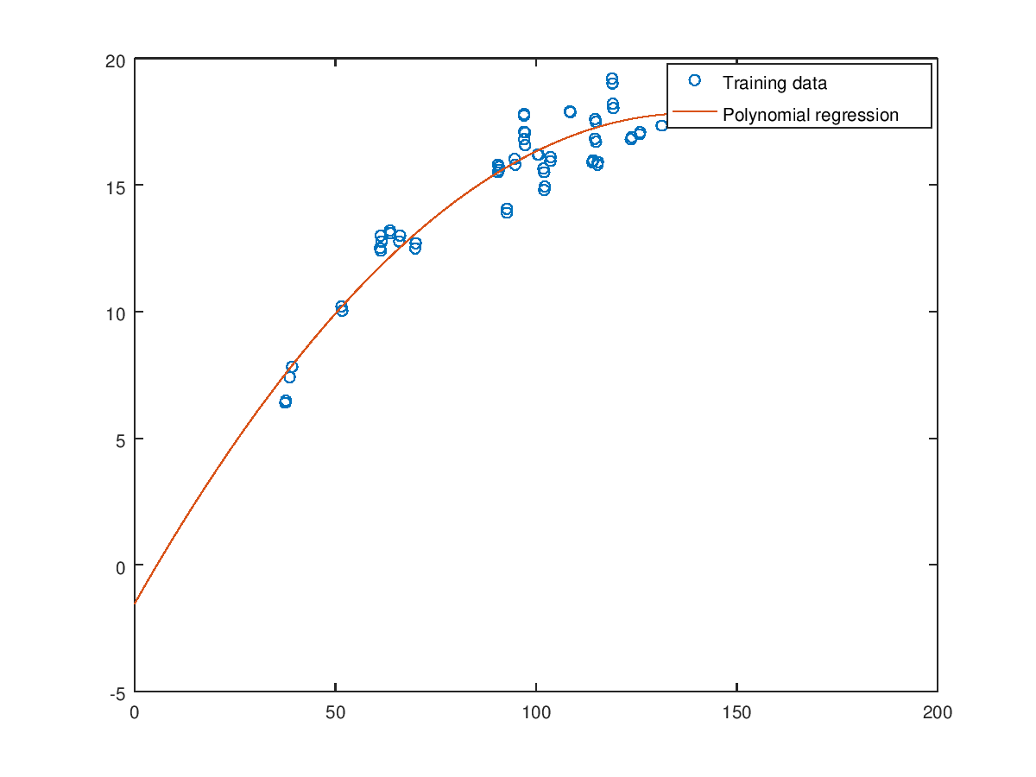

residual = 51.087